**“RFID, Fingerprint and Keypad Based Access Control and Alert System”**



**Fall 2019**

**CSE208L – Object Oriented Programming Lab**

Submitted by:

**Abdul Hadi** (**18PWCSE1624, Sec: A)**

**Jamshid Ali** (**18PWCSE1654, Sec: A)**

“On my honor, as student of University of Engineering and Technology, I have neither given nor received unauthorized assistance on this academic work.”

Student Signature: ______________, ______________

Submitted to:

**Engr. Sumayyea Salahuddin**

November 27, 2019

Department of Computer Systems Engineering

University of Engineering and Technology, Peshawar

**INTRODUCTION**

RFID stands for radio frequency identification and it basically uses the radio waves to read the information on the tag. The RFID tags contains the embedded transmitter and receiver attached to an object.

RFID is fast and does not require any contact between the reader and the tag and they can be read from feet’s away. The RFID reader performs two functions: Transmit and receive. So you can also say it a transceiver. The RFID reader contains an antenna, radio frequency module and a control unit.

In this project, we will design a control system that can be controlled with RFID, keypad and Fingerprint. To access the system, the user will have to first scan the right tag and then he will have to enter the correct password. On scanning the wrong tag or on entering the wrong password or wrong fingerprint, the system will deny access.

We will use C/C++ language in our project along with Arduino Mega as a microcontroller. We got motivated to make this project because we can make our own security control system that can be controlled with RFID, Keypad, as well as Fingerprint.

**LANGUAGE**

We’ll be using C/C++ as programming language.

**FEATURES**

Our Control and Alert system offers following features:

* Better security control system
* User will be alerted via text message when system gives or deny access.
* Working Voltage 220AC to 12 DC
* OS: Windows, Mac, Linux
* Can be implemented in many places like Hostels, Hotel rooms, Offices, Universities etc.

**HARDWARE**

* Arduino Mega
* I2C LCD
* GSM module
* Fingerprint sensor
* RFID Reader and Tags
* 4X4 Keypad or 4X3 Keypad
* 5V, 2A power adapter
* 6-12 V Power Source

**CIRCUIT DIAGRAM**

Figure 1 shows the circuit diagram/schematic of RFID and Keypad based access control system. It consists of RFID reader, GSM module, Keypad, Arduino mega, LCD and Power Source.

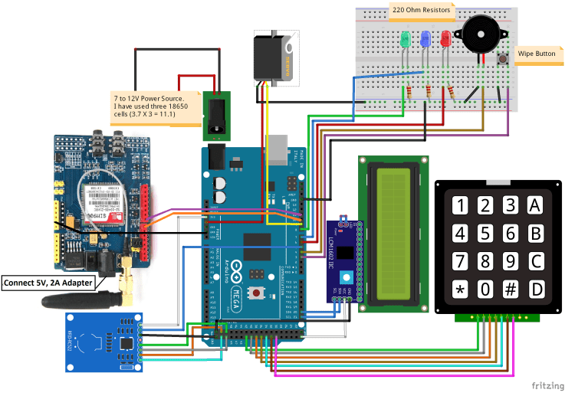

**Figure 1 – RFID and Keypad based access Control System Circuit Diagram/Schematic**

**SOFTWARE**

* IDE’s Used:
  + Arduino IDE

**COMPARISON**

* Our control system allows user to access it via many methods as compared to existing systems.
* We will use latest GSM module for better performance (SIM900).
* Low cost as compared to commercial Control access systems.

**GANTT CHART**

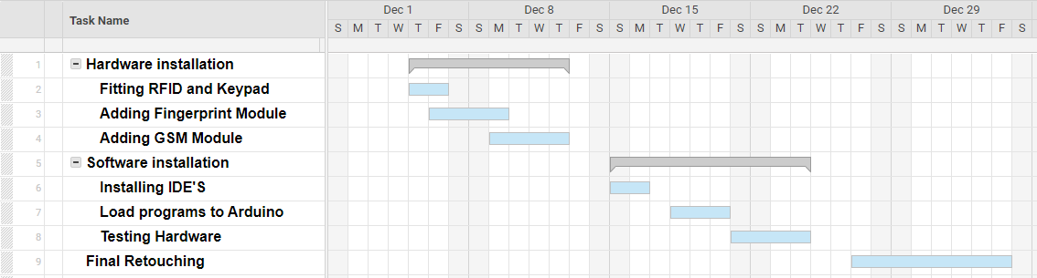

**Figure 2 – Gantt Chart**

**REFERNENCES**

1. electronicshobbyists.com (2019). RFID and Keypad Based Access Control and Alert System [online] Available at: <https://electronicshobbyists.com/rfid-keypad-based-access-control-alert-system-using-arduino/> [Accessed: 17 November. 2019].
2. lastminuteengineers.com (2019). Sending and receiving messages with GSM module [online] Available at: [https:// lastminuteengineers.com/](https://ultimaker.com/) [Accessed: 25 November. 2019].
3. Maker.pro (2019) Fingerprint Sensor Lock System. [online] Available at: <https://maker.pro/> [Accessed: 25 November. 2019].